 |  | 

study on measuring THE APPLICATION OF CIRCULAR APPROACHES IN THE CONSTRUCTION INDUSTRY ECOSYSTEM

INTRODUCTION
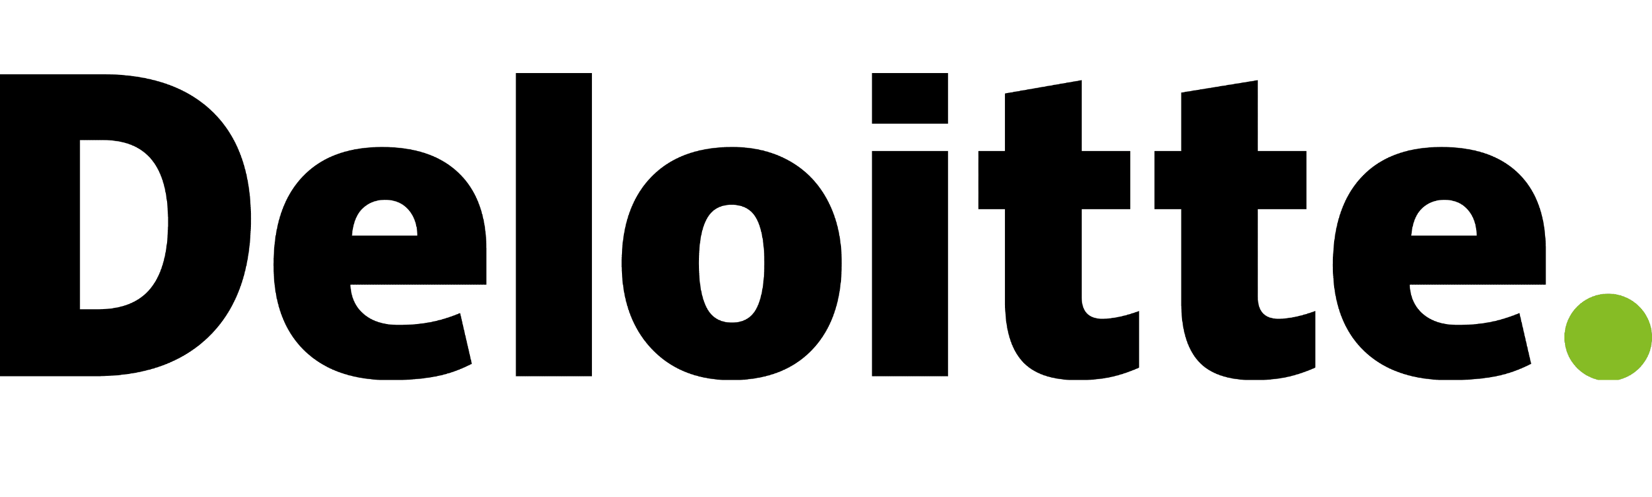
This article provides an overview of the ongoing Study on measuring the application of circular approaches in the construction industry ecosystem. This study is being carried out by Deloitte for the European Commission. A participatory workshop to share and shape our findings is taking place online on 23 March 2023 – if you are connected to the construction value chain and would like to contribute to boosting circularity in the sector, please sign up using the link at the end of this article.

 |  |  | study overview  what is the project about?  Did you know that 37.5% of the total waste generation in the EU comes from construction and demolition? And that waste generation is predicted to increase by 70% by 2050 compared to current levels? Yet, it is difficult to measure what the construction industry ecosystem is doing to address this problem and capture the value of these materials. To fully reap the benefits of a circular economy, there should be an application of different circular economy approaches by different stakeholders across the value chain. However, it is unclear to what extent this is already being done.  This study aims to boost the application of circular approaches, and their measurement, in the construction industry ecosystem across Europe.
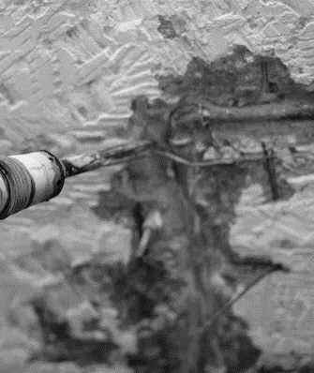

objectives

what does the study aim to achieve?
The main objectives of this study are:
- To analyse the role and ability of the construction industry ecosystem to report relevant data to support better measurement of circularity performance;
- To evaluate potential circularity indicators in the context of the uptake of circular approaches in the construction industry ecosystem;
- To gain insights into the status of the circular economy in the ecosystem across design, construction, operation and end-of-life processes;
- To highlight the drivers and benefits of circularity, and its measurement, through a series of case studies
- To analyse results and provide conclusions about optimal ways to support and measure circularity in the construction sector.

methodology

brief overview of the methodological approach
The way we understand circular economy is as a model which follows the “3R approach”: reduce, reuse and recycle, often enriched with a repair step before the recycling stage. It minimises the use of raw resources, the practice of reusing is maximised, and materials re-enter the production cycle through recycling. In the circular economy system, value is created through preserving the already existing value of products on the market. Applying, this approach would require setting up alternative business models, new and innovative services and a different organization of (global) supply chains.
The circular economy is a climate-neutral economy model that can impact resource intensive construction stages: material production, building and operation. And beyond the pursuit of waste reduction, the circular economy can also inspire innovation in technology, organization and society functioning across and within value chains which can attract the most influential stakeholders – those at the financing and planning/design stages.
This study consists of three main tasks, which are all interconnected. Each task has a specific objective, being:
- Task 1 focuses on the assessment of current data and relevant actors considering the life cycle stages of buildings and infrastructure; the stakeholders involved with decision-making and data capture/generation across these life cycle stages; and the motivations/drivers for any current data relating to circularity approaches.

- Task 2 aims to identify and select the indicators that are most relevant to supporting and/or measuring the uptake and extent of circularity approaches in the built environment. This builds upon information from Task 1 and inputs from industry stakeholders via surveys and workshops. Ultimately, a shortlist of indicators has been developed for further consultation and validation in the second phase of stakeholder engagement.

- Task 3 focuses on the definition of barriers and drivers for the uptake of circular economy approaches to collect relevant data concerning circularity indicators identified in Task 2.
To carry out these tasks, data collection is very relevant. We base our analysis on surveys targeting the construction ecosystem; stakeholder interviews; and workshops to validate the main findings and gather relevant insights from the ecosystem.
In terms of planning, this project started in May 2022 and aims to finish with the presentation of the final report in May 2023.


 |  |  |  |  | CIRCULARITY INDICATORS  It is difficult to measure progress in terms of the implementation of circularity approaches without having established methods of measurement and their required data. Hence there has been a focus on understanding what circularity indicators are actively being used and/or considered to be a high priority by representatives of the construction value chain. Some of the initial findings from the first workshop and survey include:  - There is wide-ranging support for a long list of potential circularity indicators, which include product/material, building/asset, organisational, process, urban and regional levels of measuring performance.  - Different parts of the value chain have different priorities when seeking to measure circularity performance, so the emergence of a limited range of ‘one size fits all’ indicators that have strong buy-in from across the value chain has not materialised to date.  - The level of priority placed on implementing circularity approaches was indicated either as a very high priority (63%) or high priority (24%) by survey respondents. Over half (55%) of respondents also stated that they had some indicators of circularity in place, with common indicators currently measured as:  - (whole-life) carbon (based on LCA)  - material efficiency  - construction, demolition waste quantities  - waste recovered  - recyclability of products  - recycled content/materials reused  - material flow indicators (Inputs and Outputs)  It is becoming very clear that there are large gaps between the level of priority placed upon measuring circularity performance and what is currently being measured. A key barrier is the lack of standardised metrics of performance and deficiencies in the required data.

data & barriers/drivers

Data collected and barriers/drivers for the collection of such data
The work to date has focused on scoping out the data available that could support circularity measurement and approaches involved in considering what is already in place. This includes lifecycle stage; stakeholder type; product, material, building, urban, regional etc level; and what/who is currently driving this data to be collected.
Stakeholder input has provided some insights into what data is being captured, which can be set against requirements for measuring circularity approaches such as reducing waste generation, greater reuse/recycling, designing for adaptability/deconstruction and increasing material intensity etc.
Preliminary findings suggest that the following barriers are relatively common: an insufficient regulatory approach to data together with the fragmentation of data sources, technical uncertainties associated with circular economy practices, difficulty tracking the origin of products and their constituent materials, and difficulties creating harmonised values for the indicators at an international level. In this context, it is important to develop common methods for the creation of data sets and digital tools have a role to play in this. Platforms facilitating the transfer of materials and the harmonisation of data collection practices will be necessary to implement circularity in the building value chain. Legislative requirements and other standards such as those related to Extended Producer Responsibility and the EU taxonomy, as well as Level(s), can be key in facilitating the process and driving the development of efficient tools to help organisations follow it. Such efforts have already been implemented, for example in the context of the introduction of “digital product passports”.

what’s next?

Workshop coming, stay tuned!
On 23 March 2023, we will carry out a virtual workshop (9:30 – 12:30 CET), which will focus on real case studies illustrating the application of circular approaches by stakeholders within the construction industry ecosystem. This workshop also aims to discuss the uptake of circular indicators by the industry and the way forward.
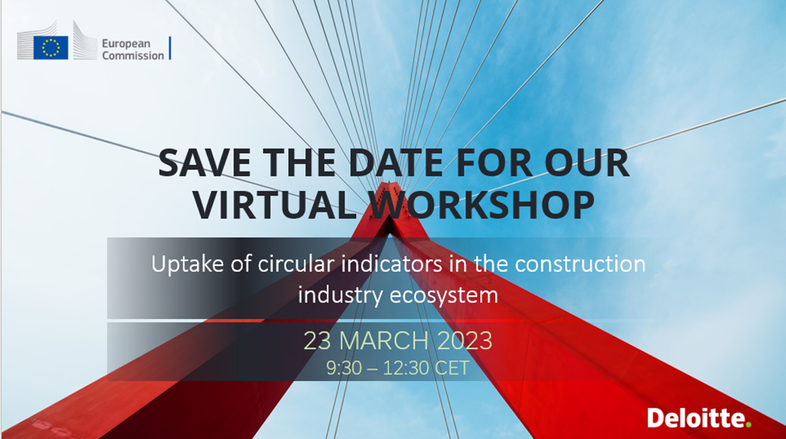
Interested? Please register here!

We want to hear from you! how do you apply circularity?
Fill out our survey here to let us know which circular approaches you are currently implementing. Your feedback will help us to assess the application of circular approaches in the construction industry ecosystem.
Feel free to reach out to EISMEA-SMP-COSME-ENQUIRIES@ec.europa.eu for more information on this exciting project!


United Nations Environment Programme (2021) Catalysing Science-based Policy Action On Sustainable Consumption And Production : The Value-chain Approach & Its Application To Food, Construction And Textiles https://www.unep.org/resources/publication/catalysing-science-based-policy-action-sustainable-consumption-and-production

